1. Demo DisplayListObject

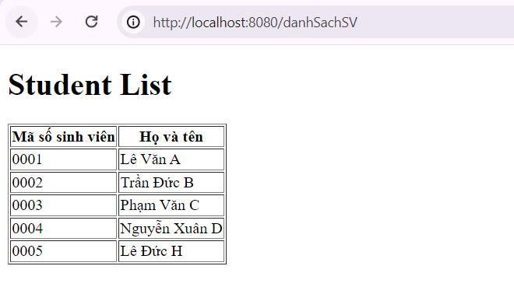

1. Demo FormSubmit_Thymeleaf

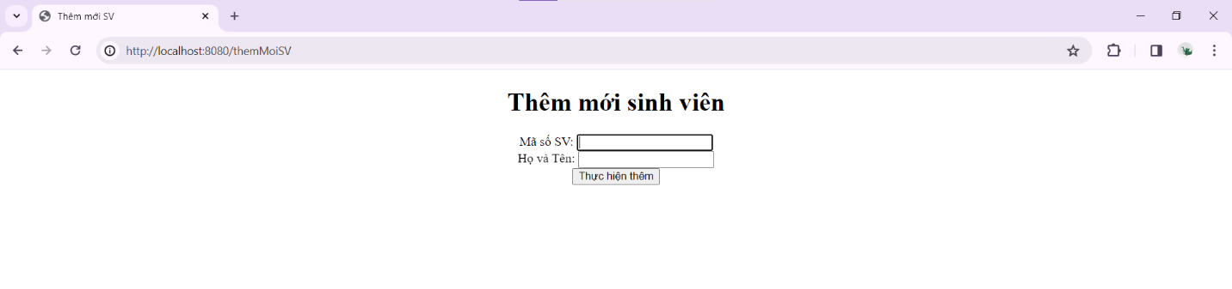

1. Demo DisplayListObjectPagination

